**Step 1: Opening/Creating a New Project**

To create a new project in Android Studio please refer to [How to Create/Start a New Project in Android Studio](https://www.geeksforgeeks.org/android-how-to-create-start-a-new-project-in-android-studio).

***Note:****Select****Java****as the programming language.*

By default, there will be two files **activity_main.xml** and **MainActivity.java**.

**Step 2: Now go to the activity_main.xml file and Add elements to the layout**

Here, we are using constrainLayout in our application where we will be using Constraints and Chaining concepts.

**Navigate to activity_main.xml file:**

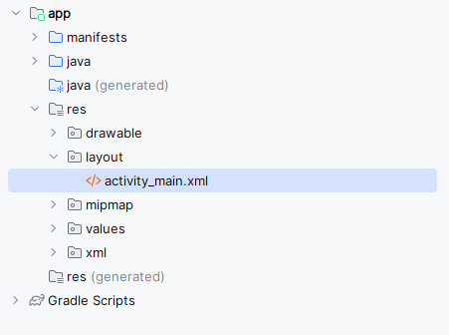

**Complete code of layout xml file as attached in xml:**

**After Complete layout xml file it will be shown as given below** :

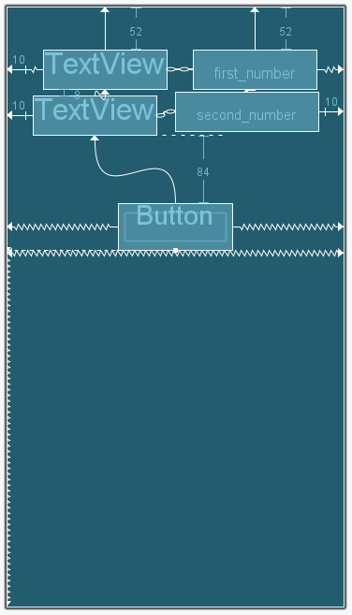

**Step 3: Now, open up the activity java file.**

**Navigate to MainActivity.java file is mentioned below:**

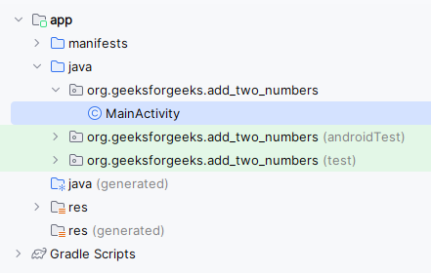

**Step 4: Changes are done in Java MainActivity file**

* Declare a few variables and the values entered in the Text Views can be read by using an id which we have set in the XML code above.
* Add the click listener to the Add button.
* When the Add button has been clicked, add the values and store them in the sum variable.
* To show the output in the result text view, set the sum in the TextView.

**Complete code of layout xml file and java file as attached:**

**Output:**

